**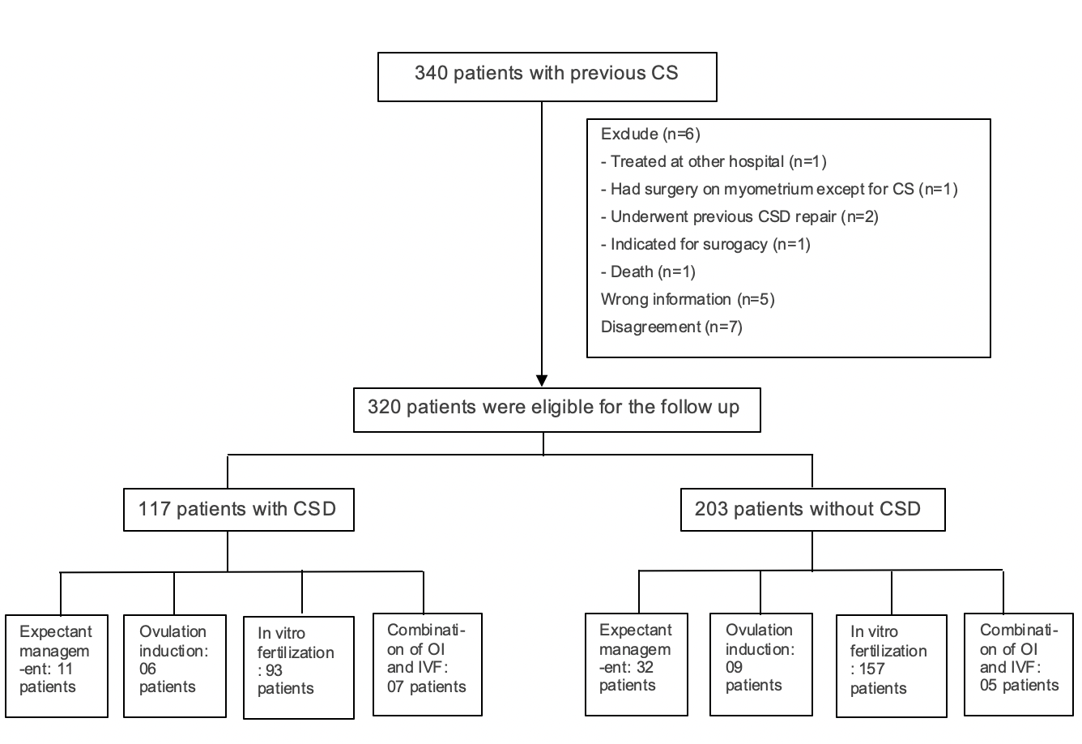*Figure 1.*** *Study flowchart. Abbreviations: CS,* *Caesarean section; CSD, caesarean scar defect; OI, ovulation induction; IVF, in vitro fertilization*

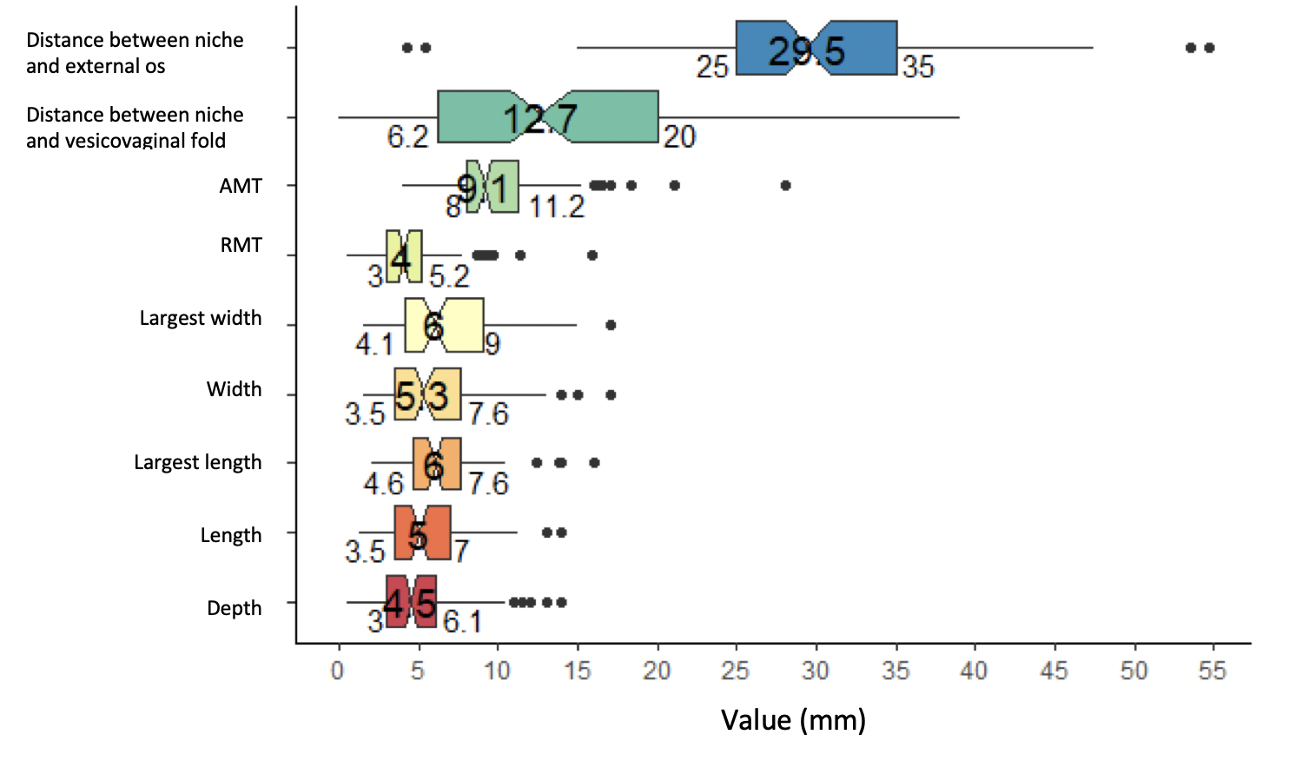

***Figure 2****. The distribution of CSD measurement*. *Abbreviations: CSD, caesarean scar defect*

*Note: Values are presented as median [25th; 75th percentile].*

***Figure 3.*** *Number of pregnancy cases*

*Note: Values are presented as number of patients (n).*